CSA5103-Cryptography And Network Security
Experiment 4
Aim:
To write a Python program to implement the Polyalphabetic Substitution Cipher (Vigenère Cipher), where multiple substitution alphabets are used based on a repeating key.
Algorithm:
- Start the program.
- Read the plaintext and key from the user.
- Repeat the key until it matches the length of the plaintext.
- For each plaintext letter:
  - Determine the shift value from the corresponding key letter.
  - Encrypt the letter using the shift value.
- Display the encrypted message.
- Decrypt by shifting each ciphertext letter backward using the same key.
- Display the original plaintext.
- Stop the program.
Code:
# Vigenère Cipher (Encryption and Decryption)
def encrypt(text, key):
result = ""
key = key.upper()
j = 0
for char in text.upper():
if char.isalpha():
shift = ord(key[j % len(key)]) - ord('A')
result += chr((ord(char) - ord('A') + shift) % 26 + ord('A'))
j += 1
else:
result += char
return result
def decrypt(text, key):
result = ""
key = key.upper()
j = 0
for char in text.upper():
if char.isalpha():
shift = ord(key[j % len(key)]) - ord('A')
result += chr((ord(char) - ord('A') - shift) % 26 + ord('A'))
j += 1
else:
result += char
return result
plaintext = input("Enter Plaintext: ")
key = input("Enter Key: ")
cipher = encrypt(plaintext, key)
print("Encrypted Text:", cipher)
plain = decrypt(cipher, key)
print("Decrypted Text:", plain)
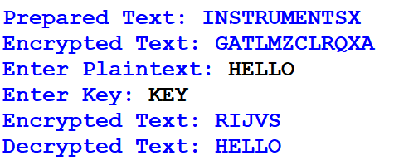
Output:

Result:
Thus, the Python program for the Polyalphabetic Substitution Cipher (Vigenère Cipher) was implemented successfully, and the plaintext was encrypted and decrypted correctly using the given key.

